WHOBUDDIES
Conservation Heroes
AIR

To receive the air natural resource and Tyto card, complete at least two items below, along with the class activity.

At home, determine where your waste products go.

With an adult go outside and fly a kite to watch different air movements.

Name two air pollutants.

What is air called when it is moving?

With an adult, take a walk or bike ride, to a place that you would normally drive to.

Class Activity- Plant a tree together as a class.

_____________________________________________________________________________________________
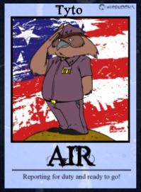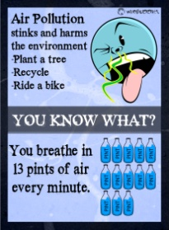
Tyto says…
- Reducing energy use reduces air pollution too.

- The tow most common forms of air pollution are ozone and particulate matter.

- One tree can produce nearly 260 pounds of oxygen a year.

- Two natural forms of air pollution include smoke from fire and dust.

