WHOBUDDIES
Conservation Heroes
ANIMALS

To receive the animals’ natural resource and Strix card, complete at least two items below, along with the class activity.

At home, watch a tree for 30 minutes to see if any animals might live there.

With an adult go outside and look for animal tracks.

Name your three favorite animals.

What kinds of animals live under the surface of the ground?

With an adult make a simple bird feeder that birds can use.

Class Activity-Go outside and identify different kinds of animal habitats.

_____________________________________________________________________________________________
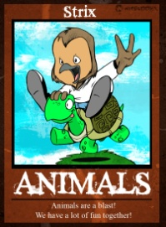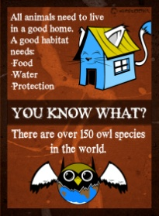
Strix says…
- 496 species of my friends are listed as threatened or endangered in the U.S.

- 1% of the original tropical rainforest worldwide are lost each year.

- The honeybee is the only insect that produces food eaten by humans.

- 6000 acres of open space is lost each day in the United States.

