WHOBUDDIES
Conservation Heroes
ENERGY

To receive the energy natural resource and Asio card, complete at least two items below, along with the class activity.

At home, check your thermostat to see what the temperature is set at.

With an adult go to a nearby park and pick up litter.

Name three ways to save energy at home.

Investigate and find out where the energy to run your school comes from.

With an adult at home, see how many of your appliances have the ENERGY STAR label.

Class Activity-Help with your school’s recycling program and discuss ways to make it better.

_____________________________________________________________________________________________
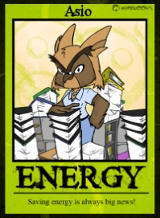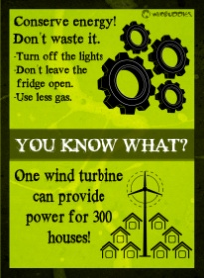
Asio says…
- The recycling of one soda pop can saves enough energy to run your TV for three hours.

- Biomass is presently the largest U. S. renewable energy source.

- A typical American household outputs 150 pounds of carbon every day.

- Recycling one ton of paper saves 17 trees and 7000 gallons of water. That is a lot!

