CLASS DISCUSSION QUESTIONS
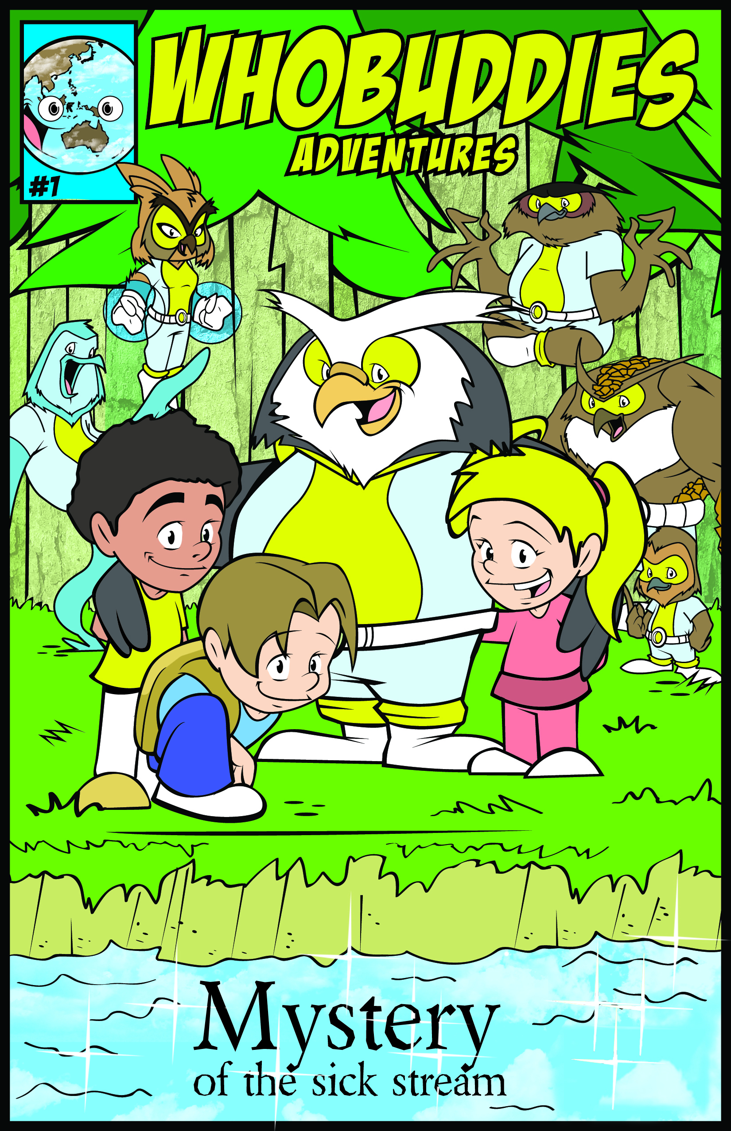

Why would the water in the stream look dirty?

What is a watershed?

What do all animals need?

What is soil erosion?

What is renewable energy?

What can you do to help conserve our natural resources?

