CLASS DISCUSSION QUESTIONS
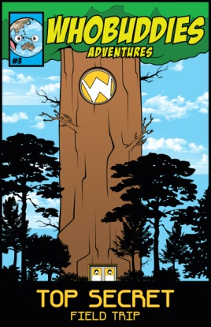

Name three ways water can be conserved in your own home.

What is the difference between renewable energy sources and non-renewable energy sources?

Describe and discuss a soil conservation practice that is common to your local area.

What three items must wildlife have to survive and thrive?

Name two sources of air pollution.

How do plants benefit the environment?

