CLASS DISCUSSION QUESTIONS
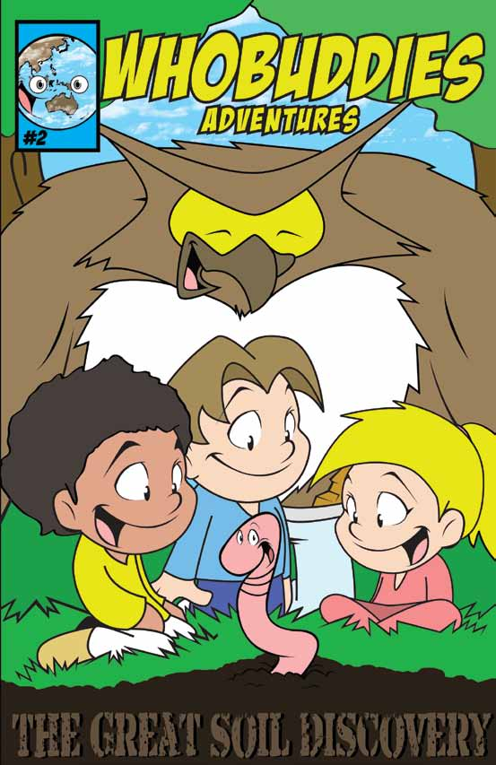

Why is it good to plant trees?

What is a tributary in a watershed?

What makes soil unhealthy?

How does soil erosion occur?

What are ways to help soil become healthier?

What is organic matter?

